

Meeting Date: September 3, 2025

AGENDA MEMORANDUM

To: Historic Preservation Board

From: Brad Boland, AICP Long Range Project Manager
Development Services

Title: Design Review: 603 North Cantril Street

Lots 13, 14, 15 & 16 Block 1 Craig & Gould’s Addition to Castle Rock

Executive Summary

The property owners of 603 N. Cantril, Sue and Scott Barnes, have submitted an application for the construction of a 624 square foot detached garage located in the rear of the property accessed by the rear alley. The property is located at the northwest corner of Sixth Street and North Cantril Street. (Attachment A).

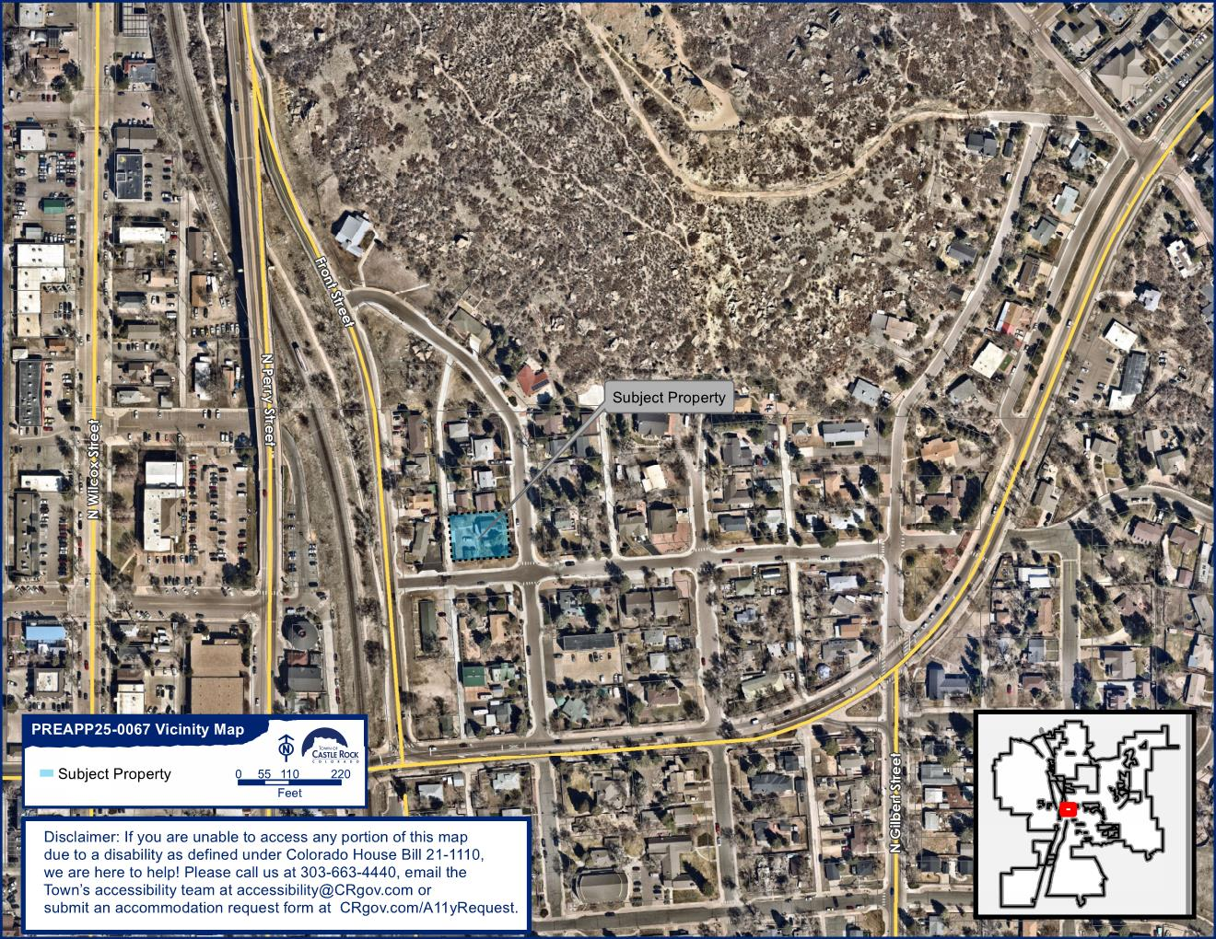
Figure 1: Vicinity map

Background

Existing Conditions and Surrounding Uses

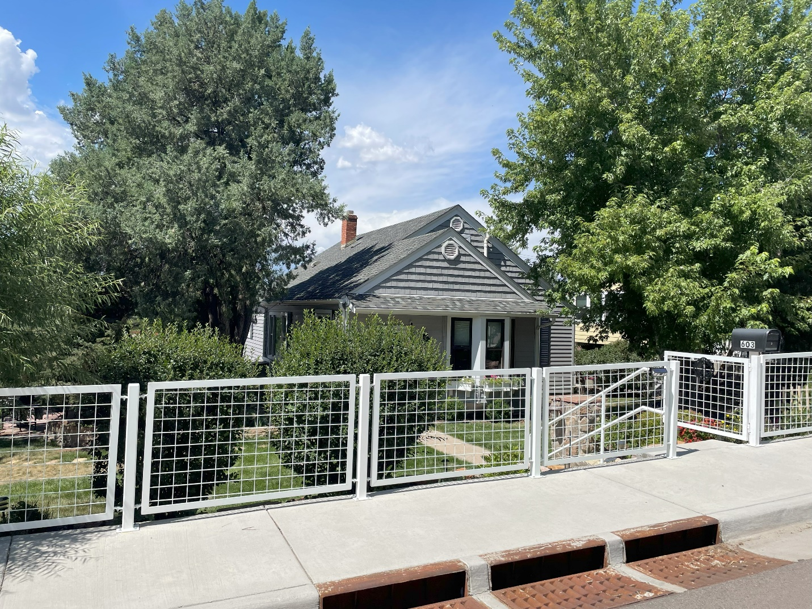
Figure 2: Front Elevation of Existing Single-Family Residence

A single-family home and accessory structures currently sit on the property. The property measures approximately 0.287 aces in size or 12,501 square feet. The surrounding area consists of single-family residences that are predominantly one-story with a few two-story residences mixed in.

The single-family house was built around 1940 and is not landmarked. Little is known about the property’s history since a detailed Cultural Resource Survey has not been completed. The house measures

Zoning Regulations

The property is zoned R-2 Single Family and Duplex Residence District. The zoning allows single-family and two-family dwellings as uses permitted by right. The proposed detached garage complies with the zoning’s development standards, including setbacks and height for accessory structures.

Discussion

Proposed Project

The applicants propose a 624 square-foot detached garage located in the north west corner of the property, accessed by a rear alley.
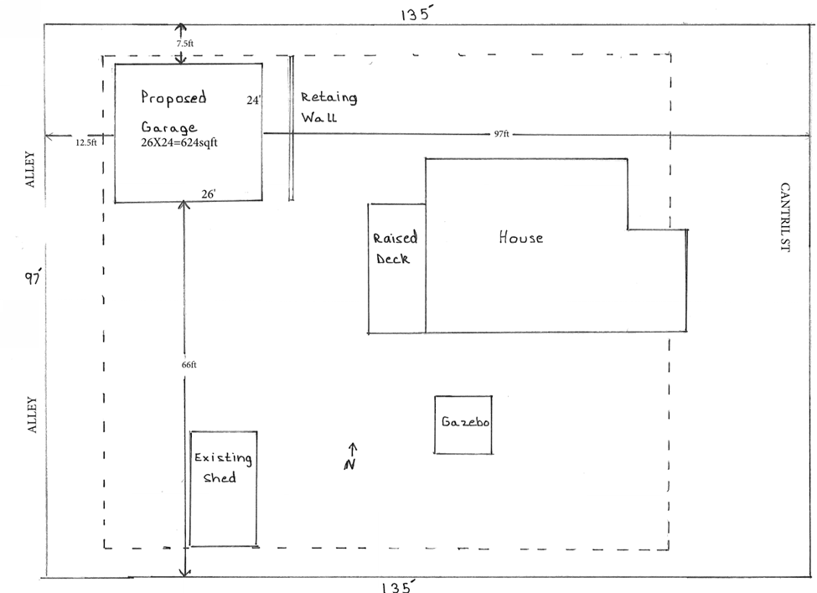
Figure 3:Site Plan

The proposed 26’ x 24’ accessory building is designed in a simple, traditional form that is compatible with the single family and is of appropriate scale and design for its location in the rear of the property. The front gabled structure features lap siding with shake singles adorning the gable ends along with an asphalt shingle roof, similar to the existing single-family residence. The garage doors, consisting of three window panels across the top of the door, are located on the south elevation. The structure is proposed to be beige with white trim.

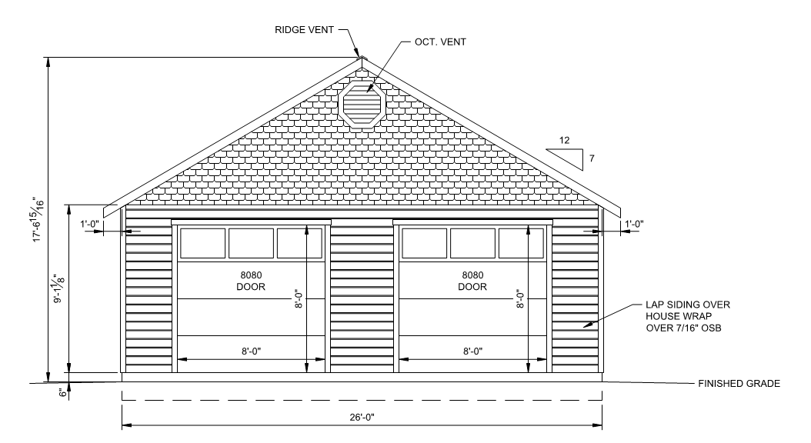
Figure 4: South Elevation

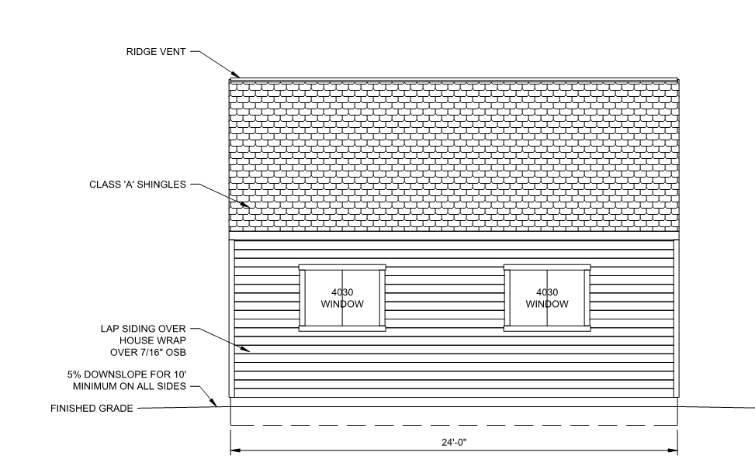
Figure 5: West Elevation

Proposed Materials

The applicant proposes 6-inch beige lap siding and white trim as shown below.

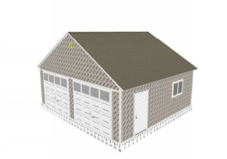
Figure 6: Photo simulation of Proposed Garage

Public Outreach and Notification

Neighborhood Meetings

A neighborhood meeting was held on August 26, 2025. No members of the public attended.

Public Notice

Public hearing notice signs were posted on the property on August 19, 2025. Written notice letters were sent to property owners within 300 feet of the property, at least 15 days prior to the public hearings.

Town staff published notice of the Historic Preservation Board public hearing on the Town's website and provided information about the proposal on the Town's Development Activity interactive map.

Analysis

The property is located within the Craig & Gould neighborhood, as depicted in the Town of Castle Rock Municipal Code (CRMC), Section 15.64.020, Figure 1. The following staff analysis is based on the representations made in the application and attachments submitted to date and the review criteria found in the CRMC Section 15.64.200 Approval for new construction and alterations to non-Landmarked properties, Craig and Gould neighborhood.

New Construction and Alterations to Non-Landmarked Properties, Craig and Gould Neighborhood Review and Approval Criteria and Analysis 15.64.200.C

- Castle Rock Style Standards

Analysis: These standards state that new construction should be compatible to the height of existing buildings, roof pitch should be consistent with the neighborhood, and building materials should resemble the traditional materials, if possible. Design elements from the Craig & Gould neighborhood that are incorporated into the new building include the gabled roof facing, lap siding, and shake shingle ornamentation of the gable ends.

- Castle Rock Design Standards

Analysis: Chapter 5, Section III of these standards include guidelines for building within the Craig & Gould’s historic residential district. New development should match the traditionally small scale of the existing buildings within the neighborhood. Materials should be compatible with those found in existing buildings. Roof forms and pitches should also be similar to provide visual continuity. Front porches are encouraged along with earth-toned building colors.

- F.R.E.S.H. Standards in Castle Rock Historic Preservation Plan

Analysis: The “footprint” of the proposed accessory structure will have a minimal impact to the surrounding neighborhood. The size and scale of the proposed gabled roofs blends with the homes within the Craig and Gould neighborhood. The proposal creates an appropriate building “envelope” for an accessory building. The proposed “skin” will be lap siding with shake shingle gable end ornamentation designed to be reminiscent of other buildings in the area. Lastly, the windows and doors, or the “holes”,” are generally consistent with patterns found in the neighborhood.

- The Secretary of Interior’s Standards for Rehabilitation

Analysis: The new construction will be compatible with the surrounding massing, size, scale and architectural features in the neighborhood.

Findings

Section 15.64.200E (2) of the Town’s Municipal Code authorizes the Historic Preservation Board to review proposed new construction and alterations in the Craig and Gould neighborhood and to approve, approve with conditions or deny the proposed new construction and/or alterations. Town staff has reviewed this application and finds that the proposal:
- Is supported by the goals and objectives of the 2030 Comprehensive Master Plan and Vision; and
- Is consistent with the goals of the Town’s Historic Preservation Plan, Castle Rock Style and Castle Rock Design; and
- Complies with the review approval criteria for new construction in the Craig and Gould neighborhood.

Staff Recommendation

Based on the analysis and findings outlined in this report, staff recommends approval of this design request.

Motion Options

Option 1: Approval
I move to approve this design review request for 603 North Cantril Street.

Option 2: Approval with Conditions
I move to approve this design review request for 603 North Cantril Street with the following conditions: (list conditions)

Option 3: Disapproval
I move to deny this design review request for 603 North Cantril Street, based on the following findings: (list reasons for denial)

Option 4: Continue item to next hearing (need more information to make decision)
I move to continue this item to the next regular Historic Preservation Board meeting on October 1, 2025.

Attachments

Attachment A: Vicinity Map
Attachment B: Plans

