Town of Castle Rock Utilities

Town of Castle Rock Utilities Financial Management Plan

Table of Contents
Executive Summary 4
Goals 4
Key Performance Indicators 4
Conclusions and Recommendations 5
Debt Management 7
Current Debt Summary 7
Refunding Bonds 7
Certificates of Participation 8
Plum Creek Water Reclamation Authority 8
Potential Future Debt 9
Debt Key Performance Indicators (KPI) 10
Debt Ratio 10
Bond Rating 10
Reserves and Unobligated Cash 11
Utilities’ Summary 11
Enterprise Specifics 11
Water, Water Resources, Stormwater and Wastewater Funds 11
Operating Reserves 12
Capital Reserve 13
Renewals and Replacements Reserve 14
Debt Service Reserve 15
Variable Interest Rate Reserve 15
Reserve for Catastrophic Failure 15
Insurance 15
Rate Revenue Stabilization Reserves 16
Current Reserves 16
AWWA Reserve Benchmark 17
Budget Performance Management 18
Revenues 18
Current Sources 18
Fixed versus Variable Revenues 18
Revenue Risk 19
Future Revenue Sources 22
Expenses 22
Current Expenses 22
Fixed versus Variable Expenses 22
Future Expenses 22
Expense Risk 23
Staffing Projections 24
Energy Consumption 24
Revenue and Expense Comparison 24
Actuals versus Budgets: Operational and Capital 29
Key Performance Indicators- Budget and Operations 31
Operating Ratio 31
Energy Consumption Efficiency (Water) 31
Water Operational Cost ($/MGD) 31
Wastewater Operational Cost ($/MGD) 32
Rates and Fees 33
Introduction 33
Rate Structure 33
AWMC Reset 33
Rates and Fee Study 33
Special Charges 34
Rate Increases/Decreases 34
Rates Hybrid Model 34
Competitive Rates with Surrounding Communities 35
Affordability Index 37
System Development Fees (SDF) 38
Competitive Fees with Surrounding Communities 40
SDF Hybrid Model 40
Balance Sheet 42
Accounts Receivable Management 42
Other Financial Management Tools 42
Interfund Loans 42
Deferred Revenues 43
Fixed Assets 43
Exhibit A 44
Long Term Staffing Plan 44

Executive Summary

The Town of Castle Rock Utilities (The Town) Financial Management Plan (FMP) is set in place to outline the Utilities main financial policies, procedures and outlays for the future. The plan also establishes the goals and the principles to guide the Utilities staff, Finance Department, Town Manager and Council members to make consistent and informed future financial decisions. Key performance indicators are used to help measure performance and develop conclusions and recommendations to drive continuous improvement.

Goals

The goals listed below for the Utilities were derived based on the Utilities’ main vision to become a national leader in the water industry and our mission to provide our community exceptional service. Each of the goals below has been set in place to help the utility achieve this. The financial management plan has been created to help guide the Utility with making the best possible financial decisions to help achieve and maintain the goals. The FMP goals are:
- To minimize future rates at or below the 2013 Hybrid Model levels
- To minimize debt carrying costs at or below industry standards
- To minimize risk by balancing fixed versus variable revenues and expenses equal or matching as appropriate
- To keep costs at or under budget for capital and operational budgets each year by fund and to continuously strive towards more efficient operations.
- To keep our rates and fees competitive with surrounding communities
- To keep adequate reserves and maintain fund balances between minimums and maximums
- To keep rates and fees affordable within various national affordability indices
- To develop regional partnerships to provide economies of scale to reduce total costs of infrastructure to our customers.
- To be an industry leader in the application of financial management benchmarking ourselves against others locally and nationally

Key Performance Indicators

In order to determine if the department is meeting the FMP goals, key performance indicators have been selected to track progress. Some key financial performance indicators that will be used by Utilities to meet the goals of this plan and the current status of these are shown below:
- Rate performance relative to the 2013 FMP
  - For the 2015 rates and fees comparison to the 2013 Hybrid model the projections are better than the 2013 Hybrid goals.
- Affordability relative to other local water providers
  - Slightly higher than the average of $47.37 at $51.08 for total fixed charges for 2015
  - Below the average of $22,019 at $20,697 for total System Development Fees (SDFs) for 2015
  - Below the average of $68.99 at $65.54 for total monthly bill for 5,000 gallons consumption for 2015
  - Slightly above the average of $109.14 at $119.44 for total average monthly bill for 15,000 gallons consumption for 2015
  - EPA Affordability Index is below the standard 1.50% at about 1.26% for 2015
- Debt Carrying Costs
  - Current combined Debt Carrying Costs at 32% for 2015
- Debt to Asset Ratio
  - Current Debt Ratio is at 19% which is in the top 25% of utilities with the lowest debt ratio based on American Water Works Association (AWWA) Benchmarking
- Bond Rating
  - Current Standard & Poor’s (S&P) Bond Rating at “AA” set in 2015
- AWWA Reserve Benchmark
  - Combined cash reserve was 408 days for 2013 which put the Utility in the top quartile
- Budget Performance
  - Has come in at or below operating budget over the last 5 years excluding amendments
  - Has come in under budget for Capital Projects for the last 5 years
- Manage the risks associated with fixed costs and variable costs to fixed revenues and variable revenues
  - For 2014 actuals Fixed revenues are at 77% of total revenues with fixed expenditures at 95% of total expenditures
  - For 2014 actuals variable revenues are at 23% of total revenues and variable expenditures are at 5% of total expenditures
- Non-revenue Water
  - Apparent Water Loss Key Performance Indicators (KPI) for 2014 is at 1.41%
  - Real Water Loss KPI for 2014 is at 6.50%
- Operating Ratio
  - Current Operating Ratio KPI is a 28% for the first quarter of 2015
  - This is in the top quartile of the AWWA benchmarking standards
- Energy Consumption
  - 2014 Energy Consumption Efficiency KPI is at 41,105 thousand British thermal units per year per million gallons (kBTU/yr/mgs)
  - This is in the bottom quartile of the AWWA benchmarking standards
- Water and Wastewater Operating Costs
  - Current Water Operating Costs KPI is at $2,520 for the first quarter of 2015
  - Current Wastewater Operating Costs KPI is at $1,867 for the first quarter of 2015
  - These are both in the middle quartile of the AWWA benchmarking standards
- Accounts Receivable Turnover Ratio
  - Currently at a 54 day turn over time period
  - Goal is 90 days or less moving forward
- System Renewal and Replacement Rates
  - At 0.8% for water which is in the bottom quartile at the AWWA benchmarking standards
  - At 2.1% for wastewater which is in the median for the AWWA benchmarking standards

Conclusions and Recommendations

From this data Utilities has been able to come to many conclusions and recommendations for the current state and future state of the business. These conclusions and recommendations below will help guide future actions and discussions in the best possible direction for the business and for the customers.
- Debt and Financing
  - Study the option of using interfund loans from water and wastewater to help minimize the rate increases needed to fund the long term renewable water plan in the water resources enterprise.
  - Evaluate options for issuing additional future debt to help fund the long term renewable water plan including options to fix a portion of the Certificates of Participation (COP) variable interest rate debt.
  - Engage a financial advisor to evaluate debt options
  - Evaluate issuing new debt as it makes sense in order to fund the needed CIP projects
- Reserve Policies
  - Reevaluate annually the reserves to ensure that the levels meet the needed standards in the industry as well as to ensure that the levels are enough to cover the needs of the various enterprises.
  - Reevaluate and consider establishing a more robust renewal and replacement reserve to ensure the long term management of the $550 million of capital assets for which the Utilities Department is responsible.
  - Establish a fatal failure reserve for stormwater to help cover and minimize risk due to the unknown weather patterns and damage that can come from storms as seen in the spring of 2015.
- Budget Management
  - Evaluate the variable expenses versus the variable revenues to take and recommend actions to council and for internal use to help minimize revenue risks.
  - Manage budgets to come in at or under budget each year for operating and non-operating budgets.
  - Continue to utilize best practices in bidding and pricing construction projects to ensure it is competitive in the market and will reevaluate each year as well as periodically as needed with new construction projects as they arise.
  - Continue to look for opportunities to maximize energy management especially given the current key performance indicator in this area.
  - Utilize our asset management plan to help reduce costs of operating, maintaining and replacing assets.
  - Reevaluate the staffing plans each year to determine the most efficient levels of staff in order to meet the needs of services and projects each year.
  - Evaluate and update special charges annually to help ensure that customers that are causing the costs are paying for the costs.
  - Improve each year with respect to dollars per million gallons per day ($/MGD) Key Performance Indicators for water and wastewater funds.
  - Minimize non-revenue water through audits and evaluating the system for leaks and breaks and other areas that can cause non-revenue water.
  - Reevaluate the yearly CIP projects to find ways to decrease costs while still completing these projects.
- Benchmarking
  - Ensure the rate and fees each year are set at or better than the 2013 Hybrid levels.
  - Compare our rates and fees to similar surrounding utilities.
  - Utilize key performance indicators to drive improvements.
  - Utilize the National AWWA annual benchmarking study to evaluate our performance on a host of financial indicators.
  - Continue to identify and negotiate regional partnerships to provide economies of scale.
- Balance Sheet
  - Look for economies of scale by the use of extra territorial service and funds raised through that service which can help pay for long term infrastructure.
  - Balance lost revenues from water conservation with other revenues or rate increases in order to fund future projects.
  - Maintain a level of 90 days or less for the accounts receivable turnover ratio throughout the year.
- Use the Financial Management Plan to support the Utilities strategic plan and be an industry leader.
The Financial Management Plan will be used to continue to support the Utilities strategic plan to be an industry leader.

Debt Management

Utilities’ is trying to minimize our carrying costs and to maximize our bond rating as noted in the Executive Summary. This section of plan reviews our current debt, compares our performance to others and then evaluates ways to reduce our carrying costs going forward. The performance of our debt also helps in the prediction pf carrying costs going forward and is a key input in our rates and fees model.

Current Debt Summary

The Utilities’ debt policy is important to many aspects of the Financial Management Plan. The current philosophy is to not issue any new debt beyond what is already committed to, although Utilities is flexible with this policy depending on the future outlooks / needs of the Utilities’ financials. The Utility plans on evaluating the need for debt on a yearly basis and will look to issue new debt if that is determined the best action to take for the rate payers.

The current debt portfolio for the Utility primarily contains Revenue Refunding Bonds and Certificates of Participation. The Utility also has Interfund Loans and Deferred Revenues on the balance sheet.

The current 2015 carrying costs for all debt combined is 32%.

Refunding Bonds
The Utility currently has two Revenue Refunding Bonds. The first is the 2006 Series for the Water Fund. The original debt amount was $9,665,000 at 4%. These fully mature in 2026 and as of December 31, 2014 have a remaining principal amount of $6,725,000. The Utilities recently called a portion of these early in order to take advantage of a savings of $303,376.91 over the course of the remaining bonds and resulted in a reduction to carrying costs. This portion has the par amount of $5,885,000 and the anticipation is a savings from a lower interest rate on the callable portion. The new 2015 series matures in 2026. The second Revenue Refunding Bonds is the 2012 Series for the Water Fund and Wastewater Fund. The original debt amount for this series was $8,705,800 at a 2.60% interest rate. These fully mature in 2023 and as of December 31, 2014 the remaining principal balance is $7,938,200.

With the review of the 2006 Revenue Bonds the Utility received an "AA" rating from Standard & Poor’s (S&P) again. The Utility was able to decrease the amount of insurance and reserves needed for these bonds. With the 2015 refunding the Utility maintained an “AA” rating from S&P.

The 2015 carrying costs for the 2006 and 2015 refunding bonds are 39%.

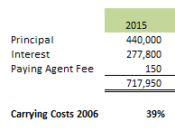
The 2012 refunding bonds 2015 carrying costs are 27%.

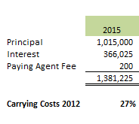

Certificates of Participation
The Utility also carries Certificates of Participation (COP) for the Water Resources Fund. The Series 2008 COPs carried an original amount of $74,795,000. The remaining principal balance as of December 31, 2014 is $66,115,000 and matures in 2037. The COPs currently have a variable interest rate, which has been trending well below 1%, but which can fluctuate up to a ceiling of 12%, plus associated fees. The COPs also have other costs associated with a letter of credit and remarketing fees. The total weekly interest rates for practical purposes, including all associated fees, have seen a range from 1.2% to 9.6%. The average total yearly rates have ranged from 1.18% to 3.56%, as shown in chart below.

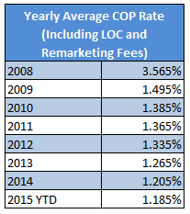

One of the action items of this plan is to identify triggers that would move the Utility to start work on fixing this debt as well as identify the time needed to complete such a transaction. Due to the volatility with the variable interest rate the Utility is currently looking at possibilities of converting a portion of the remaining principal into a fixed interest rate.

The 2015 carrying costs for the 2008 COPs are 32%.

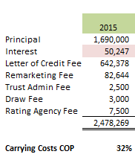

Plum Creek Water Reclamation Authority
The Utility is a member of the Plum Creek Water Reclamation Authority (PCWRA) to process the Utilities’ wastewater. The Utility is the largest member of PCWRA, attributing to 71% of PCWRA’s debt and 89% of PCWRA’s plant operating costs. The Utility receives a yearly budget from PCWRA and its 2015 obligations to PCWRA is $4,634,512. PCWRA has three debt service obligations that make up a portion of the Utility’s yearly budget, which include the following:
- Colorado Water Resources and Power Development Authority (CWRPDA) loan issued on May 1, 2001, with a 20-year term and a 3.05% interest rate. The remaining principal balance for PCWRA is $9,765,000. The Utility’s portion of this debt is 82.33% of 9.6% for restoration and 89.89% of the remaining for future capacity. The remaining principal balance for the Utility is $8,872,533.
- CWRPDA loan issued on October 1, 2002, with a maturity date in 2023 and a 1.80% interest rate. PCWRA’s remaining principal balance is $1,460,000. The Utilities’ portion is identical to the May 1, 2001 loan and the remaining principal balance is $1,326,563.
- The Clean Water Revenue Bonds 2005 Series A issued in May 2005, with a maturity date in 2026 and a 3.35% interest rate. The remaining principal balance for PCWRA is $900,000. The Utilities’ portion is 71% of the total amount leaving a remaining principal balance for the Utility of $639,000.
The carrying costs for the CWRPDA loan issued on May 1, 2001 are 28%.
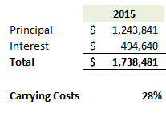
The carrying costs for the CWRPDA loan issued on October 1, 2002 are 25%.
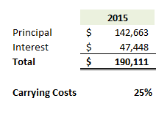
The carrying costs for the CWRPDA loan issued in May 2005 are 34%.
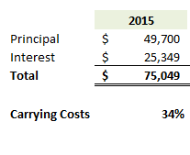
The total combined carrying costs for PCWRA debt are 28%.
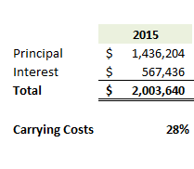
Utilities will work with PCWRA to reduce our carrying costs for this debt and evaluate options annually.

Potential Future Debt
The Utility evaluates the current debt status on an ongoing basis. The Utility currently has no plans to increase debt at this time, but will continue to monitor the needs of the four funds and determine the best possible financial models moving forward. If it is determined that this should include issuing new debt then the Utility will evaluate that path with the rate payer’s best interests in mind.

One area that could drive the Utility to issue new debt includes the Utility’s capital requirements, causing an increase in the rates and fees higher than the hybrid model projections and affordability index levels. In addition, if interest rates are low enough where the debt carrying costs are lower than pushing on the rates for customers or if the Town’s bond rating increases to where bonds become more affordable the Utility may issue new debt. Depending on the performance of the Utilities’ Key Performance Indicators (KPIs), issuing new debt can become an option as well.

Debt Key Performance Indicators (KPI)

Debt Ratio
The KPI for the debt ratio is calculated by taking the total liabilities divided by the total assets. For the Utilities’ debt ratio the water and wastewater liabilities and assets were calculated. The debt ratio for 2014 is 19% as compared to 2013 which was 20%. This is attributed to the fact that the Utility is not increasing debt as stated above. When compared to the AWWA quartiles the Utility’s debt falls in line with the top quartile, which is 20% or lower. Castle Rock is in the top 25% of utilities nationally according to AWWA’s annual benchmarking survey, with the lowest debt to asset ratio.

Bond Rating
The bond rating for the Utility is currently at an “AA” from Standard and Poor’s and an “A1” rating for Moody’s. With the 2015 Refunding Bonds the Utility earned an “AA” rating from Standard and Poor’s (S&P) once again. This rating is considered a very strong rating from S&P due to it meaning that the Utility is considered to have a very strong capacity to meet its financial commitment on its obligations and has a strong financial security characteristic. According to S&P this rating differs from the top rating by only a small degree.

Reserves and Unobligated Cash

Utilities’ Summary

Reserves are the cornerstone of financial flexibility and they allow the Utility to respond to unexpected challenges and opportunities in a timely manner. With prudent financial management and cautious planning, the Utility has accumulated significant funds in fund balance. Periodically, it is prudent to evaluate Utility policies and determine if they still fit the nature and direction of the Utility. Reserves are a critical component of fiscal stability; however, as stewards of rate payer funds, there is a need to examine when it may be appropriate to put the money to use for the community through capital projects, rate considerations or other means. The reserve philosophy should be a balance of conservative, long-term fiscal management and the pursuit of opportunities that benefit the Utility and its customers.

The Utilities’ current policy for operating reserves is to maintain two months operating expense in the operating funds, which includes personnel, supplies and services. The policy states the funds are to provide for emergencies as provided by utilities operations.

Staff has undertaken a review of the current fund balance reserve policy and considered the level of unobligated fund balances. Staff has reviewed each fund and identified certain funds where there may be a possibility to utilize identified excess funds. The reserve considerations vary by fund as each fund has its own unique aspects.

Based on staff analysis, the Utility has adequate financial reserves to maintain a conservative fiscal philosophy while having the flexibility to use funds to capitalize on opportunities if, and when, they arise.

Enterprise Specifics

Fund balance is a measure of financial resources or available cash in a fund. These balances are categorized by internal and external restrictions imposed on a given fund. Restrictions can be utilized to save money for a future capital project, set money aside for the unexpected, such as the fatal failure of an asset or in anticipation of a natural disaster.

In 2005, Town Council adopted a policy to maintain two months operating expenses in all operating funds. The intent of the reserve was to protect the town in times of economic downturn.

Consistent application of the current reserve policies and other accumulation of fund balances have resulted in significant cash balances in certain Utility funds. As part of our continuing financial analysis, we monitor these balances for reasonableness to ensure we are being fiscally responsible with rate payer funds. While there may not be one specific “right” answer, a detailed prudent review of fund balances shows there is an opportunity to clarify the purpose of restrictions and consider the use of excess reserves for the ultimate benefit of the community.

In order to provide Council with a larger picture of the funds available, and the adequacy of reserves, staff has reviewed the fund balance reserve policies to clarify intentions and also determine recommendations for the reasonableness of fund balance levels.

Staff has analyzed each fund to assess the amount of fund balance available to cover unexpected expense, loss of revenue, or opportunities.

Water, Water Resources, Stormwater and Wastewater Funds
These funds are used to account for operations that are financed and operated in a manner similar to a private enterprise, in that user charges are intended to pay for the operations. All activities necessary to provide such services are accounted for in these funds including administration, operations, maintenance, capital projects, and related debt service.

In addition to the operating reserve as instituted by Council, the Utilities department has identified other key reserves in order to ensure responsible financial management of the enterprise funds. Significant explanation of the proposed reserves for the Utilities funds is included since the amounts relative to these funds is much greater than that of any other Town fund. The recommended reserves are included for the Utilities funds here:

Operating Reserves

Generally, operating reserves in the Utilities funds are undesignated funds available for unforeseen expenses or revenue shortfalls and/or both. Each Utility fund has an operating reserve based on two months of budgeted operating and maintenance costs per the current Town policy. This policy was reviewed in light of industry standards and best management practices. The available information indicates that the reserve policy is reasonable and appropriate. For instance, operating reserves of between one to three months of operating costs are typical according to guidance from the Water Environment Federation. Given the Town’s cost structure and variability of revenues and expenses, Arcadis U.S., Inc., the Utilities Department’s rates and fees consultant, recommended that Utilities maintain Operating Reserves equal to three months of annual operations and maintenance expenses. Arcadis U.S., Inc., also noted correctly that additional significant incremental operations and maintenance costs would be realized over the next 5 to 10 years as the projects associated with the Long Term Renewable Water program come on line. An increase in operating reserves now, specifically in the Water Resources Fund, could avoid potential rate spikes in the near future. Utilities will continue to evaluate the efficacy of this proposed change.

The types of events that could warrant the use and the amounts of operating reserves based on our actual operations have been evaluated and examples are below.
- A cyber-attack that impairs our ability to accept bill payments in our online or main billing systems for several months
- Sudden increases in chemical or energy costs due to changes in market conditions or shortages of raw materials
- A flood which deposits a large amount of sand and debris on public roads
- Revenue deficiencies in the bond fund created for payment of principal and interest on our revenue bonds
- An increase in the interest rate above 3.5% on our variable interest rate COPs
- A change in our wastewater providers ability to dispose of bio-solids
- An extended drought which requires outdoor irrigation to be curtailed
- A large change in development activity
- A significant change in the administration of water rights on Plum Creek by the State Engineers Office.

Staff has recommended that the rate revenue stabilization reserve (see below for more on this reserve), which is really a specific type of operating reserve, be combined and absorbed into the Operating Reserve. Rather than restricting this reserve to fluctuations in revenues driven solely by weather, Staff believes using this reserve for any of the purposes for which an operating reserve is typically created provides additional flexibility.

Capital Reserve

The Capital Reserve component includes reserves designated for specific capital projects, including renewals and replacements as well as improvements as is primarily seen in the Water Resources Fund. The capital reserve varies from year to year and fund to fund. According to industry literature, typical capital reserves for Utilities are in the range of 2% of net asset value or 5% of prior year’s revenue. As explained by an article through the Environmental Finance Center of the University of North Carolina at Chapel Hill, Utilities that primarily fund capital from rates and fees tend to have higher reserves than those that rely more on debt financing. Utilities’ rates and fees consultant validated this through their recommendations to Utilities on capital reserves. The article noted reserves of 1.7 time’s annual operating expenses for Utilities from the study with this strategy (Castle Rock is between 1.4 and 2.5 depending on fund). Additionally, for Utilities that fund capital projects from rates and fees, rate volatility tended to be lower than Utilities that rely on debt financing for capital projects.

Based on Council direction, the primary strategy for funding future capital projects in recent years has been to fund those projects from rates and fees on a “pay as you go” basis (i.e. issue no new debt beyond our current obligations). Debt financing has been used in the past for the Water, Wastewater and Water Resources Funds and current debt totals around $83 million. In order to ensure funding is available for renewal and replacement and improvement projects included in the five year Capital Improvement Plan without causing single year rate spikes, Utilities has designated available funds to specific projects in the Capital Reserves. A listing of the current capital reserve designations is provided:

Fund | Project | Amount Reserved
Water | Diamond Ridge Pump Station Upsize | $135,504
 | Administration & Customer Service Building | 1,403,640
 | Site Improvements – 175 Kellogg Court | 1,078,827
 | Total | $4,829,249
Water Resources | Water Rights (Rothe and Others) | $12,000,000
 | Purchase Capacity in PWSD RHWTP | 8,000,000
 | WISE Project | 4,336,743
 | Rehabilitation of Alluvial Wells Fields | 600,000
 | Chatfield Reallocation Project  Aquifer Storage and Recovery | 2,480,748  1,000,000
 | Box Elder Creek Properties Property Purchase | 8,157,000
 | Box Elder Creek Properties Options Payments | 600,000
 | Box Elder Creek Properties Due Diligence | 129,000
 | Foothills Raw Pipeline & Pump Station | 100,000
 | Newlin Gulch Pipeline & Pump Station | 100,000
 | Site Improvements – 175 Kellogg Court | 500,387
 | Administration & Customer Service Building | 627,940
 | Total | $38,631,818
Stormwater | Site Improvements – 175 Kellogg Court | $489,864
 | Industrial Tributary Stabilization | 680,281
 | Administration & Customer Service Building | 638,165
 | Total | $1,808,310
Wastewater | Craig & Gould North Infrastructure Improvements | 355,000
 | Rehab/Replacement at PCWRA  Malibu Street Upsize  Site Improvements – 175 Kellogg Court  Prairie Hawk Interceptor | 670,083  387,000  594,624  417,000
 | Administration & Customer Service Building | 588,308
 | PCWRA Capital Buy-in | 11,059,295
 | Total | $14,071,310

This approach to capital reserves was validated by Utilities independent rates and fees consultant. In fact, Arcadis U.S., Inc., U.S., Inc., recommended Utilities maintain higher capital reserves to provide an accounting for future impacts of needed renewals and replacements. This is especially true for the Water Fund where Utilities has as much as $80M in fully depreciated assets. When Utilities benchmarked typical cash requirements for renewals and replacements against Utilities nationally through the American Water Works Association (AWWA), the recommendations of the consultant were corroborated. It was determined that we are investing much less in renewals and replacements than the median for Utilities in the survey. As our infrastructure ages, additional capital reserves may be required to continue to rate fund capital renewals and replacements as recommended by our rates and fees consultant. For example, using the median expected renewal and replacements from AWWA, an additional $4 million of capital reserves could be easily justified in the future.

Most of the capital reserves are associated with the Long Term Renewable water program in the Water Resources Fund. Projects in the Water, Wastewater and Stormwater include more of a mix of renewals and replacements and improvements, with improvements still being the lion share of the reserves. Accumulating capital reserves for designated projects is an important piece of managing rates and fees and avoiding spikes in the same. Utilities will begin developing a specific Renewables and Replacements reserve with totals for these reserves by fund. Utilities is in the process of determining what these amounts should be.

Staff will continue to allocate accrued revenues to capital reserves as revenues become available, prioritizing the allocation to the most important projects based on the current CIP. This will be done on at least an annual basis.

The Utility continues to engage an independent firm to perform a rate and fee study each year which takes into account the capital funding strategy. The rates and fees assessed are based on long term strategic capital planning for the water funds and enable the enterprises to accumulate the funds needed to complete the projects. Long term financing options have been used in the past and may be evaluated for use in the future. For reference, the Utilities funds currently have a very low debt to asset ratio relative to other Utilities that participated in 2014 AWWA benchmarking survey. While staff continues to believe this is an indication of good financial management, use of more financing is a useful tool and could reduce reserve requirements in the future. Staff will continue to evaluate financing options as a part of the financial management of the funds and provide recommendations to Council annually.

Renewals and Replacements Reserve

The Utility is currently in the process of updating the reserves to possibly include a renewal and replacement of assets reserve. The utility has been growing and building so much that having a reserve in place to renew or replace aging infrastructure is going to be an important financial tool for the future. The current thought process is that the reserve will be based on industry standard practice for design life of the various assets and acceptable risks for different asset classes. The utility can use the asset replacement schedule that is created in order to create a schedule of costs needed for the reserve. The reserve amount will be calculated using the Replacement Cost New values times the renewal and replacement percent for the type of asset, typically 1.5 to 1.9%.

Debt Service Reserve

The Utility maintains about $4.6 million in debt service reserves within the Water Resource Fund. The outstanding Certificates of Participation (COP) debt does not require a specific coverage ratio. In lieu of coverage, the Utility is required to maintain this debt service reserve per the bond document. This is an external restriction that cannot be modified other than through a refunding or restructuring of the debt instrument.

Variable Interest Rate Reserve

In 2008, as part of the overall long-term water initiative, the Utility issued $74 million in COP's to secure water storage rights in Reuter Hess Reservoir and also to construct the Plum Creek Water Purification Facility. At the time of issuance, Town management with the advisement of Council and the Utility’s investment banker and financial consultant, determined a variable rate instrument would be most advantageous given the market conditions and economic outlook. The fixed rate at the time of issuance was approximately 3.35%; the actual rate over the past 6 years has averaged 1.7%. Each year interest expense is budgeted at 3.35%; however, actual interest has trended significantly lower. This savings has been identified and reserved in fund balance to offset future increases in interest rates should they rise above the budgeted 3.35% (potentially pay down the outstanding principal balance, or used if it's advantageous to fix a portion of the debt issuance to hedge against future rate increases). Approximately, $1.6 million is reserved in the Water Resource Fund. It is important to note that the cap on the variable interest rate COPs is 12%. If the interest rate were to spike to this level, annual principal and interest payments would exceed this reserve by as much as $6 million, which supports the continued need for the operating reserves. Fixing the COPs would allow this reserve to be allocated to capital reserves.

Reserve for Catastrophic Failure

The “fatal failure” reserve is a type of capital reserve that would be available in case of a catastrophic failure of a major asset within one of the funds. For the Water, Water Resources and Wastewater Funds, the amount reserved is approximately 2% of the original value of the capital asset. Again the current approach used by Utilities was reviewed in light of best industry practices. Results of this analysis showed that the current reserves are reasonable and consistent with industry standards. As noted by Arcadis U.S., Inc., the Utilities Department current emergency reserve target is consistent with common water industry practice. Utilities often set this target at 1 or 2% of asset value or equal to the replacement cost of a major or critical portion of the system. In order to fully vet the need for the catastrophic failure reserve, staff also looked at current insurance coverage for our major Utilities infrastructure assets.

Insurance

Liability insurance provided through Colorado Intergovernmental Risk Sharing Agency (CIRSA) specifically excludes underground infrastructure, but it will cover damages to third parties caused by any waterline breaks, sewer backups, etc. less the deductible ($100,000) up to $5 million per claim. Any damages to aboveground infrastructure may or may not be covered depending on the cause of the damage. Mechanical/electrical system failures caused by internal factors, would be excluded from coverage. Internal factors include, but are not limited to the following:
- Planning, zoning, development, surveying, siting;
- Design, specifications, workmanship, repair, construction, renovation, remodeling, grading, compaction, unless fire or explosion ensues and then only for direct loss or damage caused by such ensuing fire or explosion;
- Materials used in the repair, construction, renovation or remodeling;
- Maintenance;
- Wear and tear;
- Rust, corrosion, fungus, decay, deterioration, hidden or latent defect or any quality in property that causes it to damage or destroy itself;
- Settling, cracking, shrinking or expansion; or
- Dampness or dryness of atmosphere, changes in or extremes of temperature, marring or scratching.

Damage to aboveground infrastructure would be covered if catastrophic failure is caused by an act of God or nature (e.g. tornado) minus the deductible. As noted previously although the Town may receive funding through Federal Emergency Management Agency (FEMA), the State and our insurance provider during such an event, it is important to have sufficient cash reserves available to meet immediate needs as reimbursements from third parties may not occur until months after the event.

Based on the review of insurance and the new replacement costs of many of Utilities critical assets, the existing catastrophic failure reserves will cover replacement of some of the critical assets. For example Utilities has a number of critical water tanks that could easily cost $3 million or more to replace. The failure of a large critical water transmission or sewer collection main could easily cost more than $500,000 to repair or replace. If a raw water well suddenly had to be replaced due to some sort of failure, this cost could easily exceed $1.5 million. Existing reserves would not fully cover the complete loss of a water plant or reservoir, but could provide a reasonable start towards recovery. Finally, it should be noted that Utilities has been working to establish a fatal failure reserve in the Stormwater Fund, but adequate financial resources have not been available to fully fund it. Staff believes this should continue to be a financial goal in the next several years. The storms of June 2015 have shown the importance of a stormwater fatal failure reserve with $1.6 million in damages to the system occurring. Utilities will continue to work towards funding a stormwater fatal failure reserve at 2% of total assets.

Rate Revenue Stabilization Reserves

The Rate Revenue Stabilization reserve is specified by ordinance and has been set up to offset the potential loss in revenue due to weather conditions, primarily temperature, which result in a significant decrease in water consumption and corresponding revenues. Utilities calculates this reserve by taking the coolest year on record over the last 30 years and looking at the reduction in demand that occurred. This reduction is extrapolated to the current customer base to come up with a reduced consumption and revenue based on current rates and fees. As the customer base grows, this reserve will correspondingly need to grow.

The 2015 proposed budget amount for this reserve was $1 million increasing over time with the revenue projections for the Water Fund. As noted under the section on operating reserves, staff believes the ordinance requiring this reserve should be updated to become part of the overall operating designation thereby creating additional functional flexibility in the use of reserves to meet needs. Utilities will work towards this change in 2015 and 2016.

Current Reserves

Staff recommends maintaining the current reserve policies and approaches for Utilities funds in the near term with the noted exception that the rate revenue stabilization reserve should be combined with the operating reserves. There are currently some unobligated cash reserves in the Water ($.2 million) and Wastewater ($1.7 million) Funds. Utilities plans to put some amount (to be determined based on the 2016 budget and the needs of the department) into a capital rehab reserve. Utilities also recommend establishing a fatal failure reserve of $1 million for the stormwater enters. Also, Utilities will evaluate the efficacies of increasing the operational reserves associated with increased Operations & maintenance (O&M) for infrastructure installed as a part of the long term renewable water plan.

Further recommendations for uses of any currently identified unobligated funds will be part of this analysis including evaluating options such as paying down debt, rate management, Interfund loans to mitigate future rate increases (especially in the Water Resources Fund), economic development that benefits Utilities rate payers, additional transfers to the capital reserves for renewals and replacements in accordance with the recommendations of our rates and fees consultant, and unplanned capital opportunities among other potential options.

AWWA Reserve Benchmark

The AWWA tracks cash reserve amounts in number of days of cash available. For the 2014 survey the cash reserve in days for water was at 2,064 day and for wastewater was at 521 days. The total combined cash reserve in days for the utility is at 1,549 for the 2014 survey. This places the Utility well above the top AWWA quartile for this KPI, which is set at 408 meaning that the cash on hand is more than adequate.

Budget Performance Management

Budget Performance Management is an important aspect for the Utility. Included in Budget Performance Management are the tracking and understanding of each Enterprise Fund’s revenues and expenditures year over year, staffing projections, energy consumption and the largest components of our budgets, and how the actuals compare to our budgets from both an operational and capital perspective.

Revenues

Current Sources
The Utilities’ revenues come from a few different sources. The primary source of revenues comes from rates and fees or charges for service. These are both volumetric and fixed rate revenues based on the rates and fees approved by Council each year. The revenues for water come in based on a fixed charge of $9.54 (3/4” meter) per customer for 2015 and a volumetric rate at a minimum of $2.75 per 1,000 gallons (Tier 1 Rate). The renewable water monthly service charge is $25.39 for 2015 (3/4” meter) per customer. The monthly stormwater rate is $6.85 per single family equivalent (SFE) per month. The wastewater revenues are based off of a volumetric rate of $6.59 per 1,000 gallons and a monthly service charge per customer of $9.54 (3/4” meter). These will be further discussed in the Rates and Fees section below.

A second source of revenues comes from System Development Fees or Special Assessment Fees. Water, water resources and wastewater fees for revenues are assessed at the time of permitting and are for the right to access existing system capacity or for payment of a proportionate share of the capital cost to add capacity to meet the new potential demand on the system. The cost to add stormwater capital facilities to manage runoff is another source of revenues with new permits. The revenues will vary depending on meter size, location of the new development and number of permits anticipated to be issued. These will be further discussed in the System Development Fees section below.

Other sources of revenues for the Utility consist of other charges for services, contributions and donations, fines and forfeitures, intergovernmental revenue, investment earnings, other special assessments, transfers in and other revenues.

Fixed versus Variable Revenues
The Utility understands that fixed versus variable revenue tracking is important to remain successful. It is important to ensure that fixed revenues can cover fixed expenses and the utility will continue to work to not rely on variable revenues to cover fixed costs. This helps to promote successful cash flow during tougher economic times or during times of low consumption. This also allows for adjustments to be made to variable expenses as variable revenues fluctuate so the Utility can adjust to covering all costs with the incoming revenues.

Fixed versus variable revenues for the Utility vary based on the enterprise fund in which they are housed. The water fund fixed revenues for 2014 and estimated 2015 add up to about 25% of the total revenues. The fixed revenues for the water fund include items such as revenue bonds, some fixed metered water sales, reimbursements, fines and forfeitures and special assessments. The 76% of the water’s variable revenues includes variable metered water sales, water leases and bulk water sales. For water resources the variable revenues total only 1% of the total revenues and include water surcharge fees. The rest of the revenues include COP proceeds, reimbursements, water resources fees, water violation and lien administrative fees. The stormwater and wastewater funds have no variable revenues. Stormwater fixed revenues include stormwater charges, market changes, grading, erosion and sediment control (GESC) fees, drainage, erosion and sediment control (DESC) fees and miscellaneous revenues. Wastewater fixed revenues include wastewater charges, capital reserves, lien administrative fees and other miscellaneous revenues.

Managing fixed versus variable expenses is a key to remaining successful. This becomes part of managing risk with revenues and expenses. Knowing and understanding the risks that can be involved with fixed and variable revenues can help the Utility to adjust expenses throughout the year in order to maintain healthy books. Overall fixed revenues should match fixed expenses and this outlines the main player in managing risk with the variable revenues versus expenses.

Revenue Risk
The Utility is constantly at a level of risk in terms of revenues. There are a number of risks that the Utility has and will continue to evaluate including customer consumption patterns related to weather and conservation, growth and development, regulatory changes, changes in large customers especially commercial customers (e.g. going out of business, changes to site, and changes in consumption) and non-revenue water. The scale of potential revenue risks are shown below by category:

Weather | 2,327 million gallons (mg) in a wet year and 2,811 mg in a dry year, which could cost up to $1.5 million a year
Consumption | Could range from $10 million to $60 million total between 2015-2020
SDFs | Could be up to $59.4 million total between 2015-2020
Large Customers | 18% of current revenues worst case approximately $1.9 million of water revenues
Commercial Stormwater | Up to $1.1 million or 45% of total service charges in a typical year
Non-Revenue Water | Approximately 236.259 mg/yr or approximately $245,000 a year

More information on each of these is provided in the following sections.

Revenues can vary depending on the number of customers as well as the usage by the customers. If there is a wetter season then less watering will occur which would mean less revenues from water usage. The Utility has determined that there is a need to track these risks closely when working on projections for future rates as well as future budgets for revenues and expenditures. In 2014 water consumption decreased due to an increase in rain and conservation. An increase in customers has helped to balance out this risk, but the Utility knows that it needs to work to track and determine revenue risk predictions up front in case customer growth slows down. Currently, the Utility is tracking the production of water and consumption of water as compared to the same months in 2014. Also being put into place is a revenue risk projection tracking tool that will allow revenue to be projected for collected rates and fees based on customer count, new permits and average usage. This tool will be used to help in risk mitigation as well as with how the Utility foresees rates being set in future years.

SDF and Growth Projection Risk
There are many examples of revenue risk that are considered for the Utility. Some of these include the risk related to SDFs and growth projections. If the projected numbers are higher than actual growth the town would be at a risk for overstating revenues which if not tracked properly can lead to overspending. The charts below show examples of what can occur with different growth projections in terms of revenues.

Consumption Risk
User consumption and conservation is a revenue risk as well. If less water is used then less water is produced and less revenue is created for the Utility. The opposite holds true as well. This can be due to weather (see below) or also due to customers conserving more water on a daily basis. Impacts can be shown in the chart below as well.

Current Revenue Projections (Good Growth Scenario)

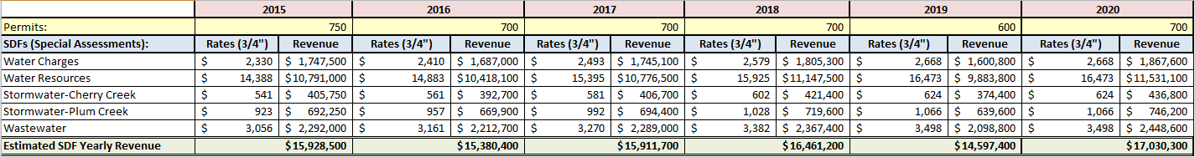

Low Number of Permit Risk (Based on low permits of 260 since 2008, pulled from 2014 CAFR)

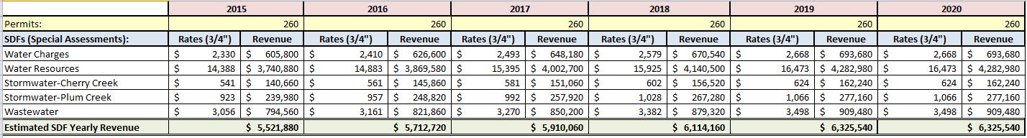

Weather Risk
The weather can play a large part in revenue risk for the Utility as well. No one can predict if it will be a rainy cool summer or if it will be a dry and hot summer. This can decrease or increase the amount of water being used during the busy irrigation seasons leaving unpredictable revenues throughout the seasons causing fluctuations in revenues and in anticipated expenditures. The Utility uses a water demand prediction model to help with weather and demand outlooks. This model looks at growth and different weather conditions to predict the monthly and yearly water demand. In the past year the Utility looked at a number of different historical weather data points to model the predicted demand as shown in the graph below.

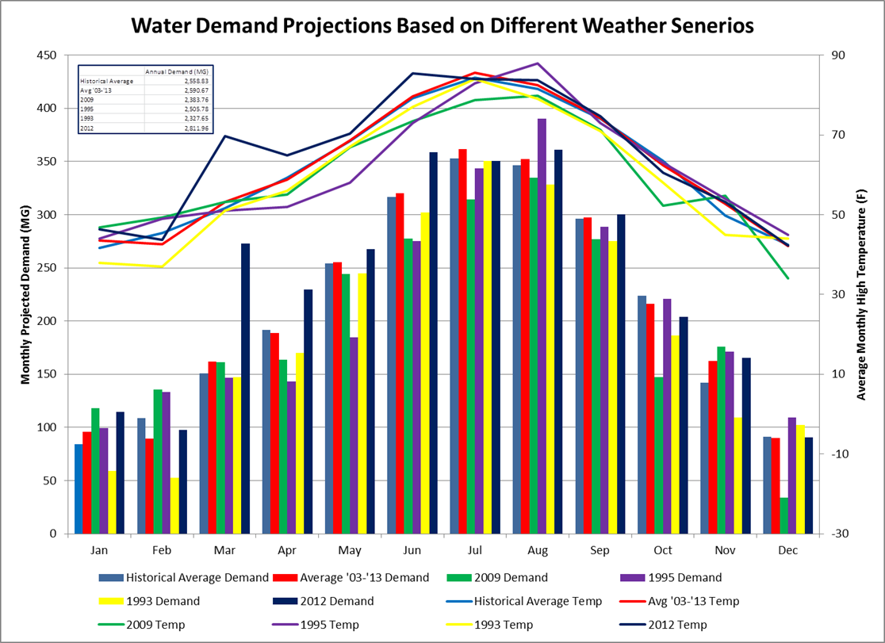

Based on current customer counts, 30 years of weather record, and current rates, revenue risk from reduced waters sales could be as much as 2,327 million gallons (mg) in a wet year and 2,811 mg in a dry year. This helps set the rate revenue stabilization reserve.

Large Customer Risk
The Utility tracks the largest 25 users which account for 18% of water and wastewater revenues. Changes to these entities could cause risk to the revenues we gain from them. Most of the largest customers are commercial entireties and homeowner associations (HOAs). Some of these risks can include a business closing or changing sites and not being replaced immediately after which can cause a decline in water sales and revenues. Another risk is a reduction in water usage. If this were to occur it could potentially be a huge loss of revenues due to these entities having such large usage normally.

Stormwater 80% Commercial Site Impervious Risk
Another revenue risk to the Utility is the Stormwater 80% Commercial Site Impervious risk. This has to do with the 80% being an average assumption of impervious area for billing purposes and the Town follows the process in the municipal code that allows a property owner to appeal the 80% rule if they believe their property is actually less than 80% impervious. The risk lies in the potential for all non-residential property owners to submit an appeal and for the actual average impervious area of all non-residential property to be less than 80% thereby reducing revenue. Commercial stormwater revenues account for $1.1 million or 45% of the total service charges.

Non-revenue Water Risk

By tracking non-revenue water the Utility can determine how much revenue is lost because of water that is being used and not being charged for. The Utility tracks the following two KPIs for non-revenue water. These include the apparent water loss and the real water loss.

Apparent Water Loss
The apparent water loss KPI is calculated using the total volume of water lost due to unauthorized consumption, customer meter inaccuracies and systematic data handling errors divided by the average daily production times 365 days. The KPI for 2014 is 1.41%, which equates to how much revenue is lost. This is important because it shows errors either on the system or hardware sides and can help the utility determine where fixes can possibly be put into place to reduce these errors and help give the most accurate revenues for the future.

Real Water Loss
The real water loss KPI is calculated using the total volume of water lost due to leakage on transmission and distribution (T&D) mains, leakage and overflows at tanks and leakage on service connections up to the meter divided by the average daily production times 365 days. The KPI for 2014 is 6.50%, which equates to how much revenue is lost. This is important for the utility because it shows how much water we can be losing due to these leaks and overflows. This can become significant losses in revenues if these are not corrected quickly and accurately. The utility tracks these but also can use this data to help determine areas where potential future risk may exist as well.

Overall non-revenue water in either situation is a risk to the utility due to the loss of revenue and the expenses that can occur from fixes to these issues as they arise.

Future Revenue Sources
Future sources for revenues for the Utility include a projected increase of customers on the system. The projected growth rate is anticipated to remain steady over the next fifteen years averaging about 600 new single family units per year. The Utility also anticipates a growth in commercial customers over the next several years with the build out of the Promenade and future commercial buildings in downtown Castle Rock.

Expenses

Current Expenses
The Utilities’ current expenses involve a few different areas of expenditures. Each of these areas is closely budgeted and monitored in order to stay within the anticipated revenues each year. In order to stay within budget each year and to help minimize rate impacts, the Utility analyzes expenses each year through a year-end estimates process as well as updating a new five year budget plan each year. This includes normal everyday expenses down to CIP driven expenses. The categories of expenses include capital, debt and financing, personnel, services, supplies and transfers out and other miscellaneous items. In 2014 actuals and 2015 projections, the largest portion of expenses come from capital projects and then services and personnel. Capital projects top the list as they include improving and updating infrastructure, renewable water projects and other important projects to help maintain and improve the Utilities’ system. Overall the Utility works to maintain the even balance between revenues and expenses and works to maintain that level year after year.

Fixed versus Variable Expenses
Fixed versus variable expenses for the Utility varies depending on the enterprise fund similar to that of the Utilities’ revenues. For the water fund, the fixed expenses equal about 76% of total expenses. These include capital, debt and financing, personnel, services, supplies and transfers out. The 24% of variable expenses in the water fund include services and supplies, which includes gas, electric and stormwater sewer expenses. For the water resources fund fixed and variable expenses include the same categories as the water fund, but water resources is about 93% fixed expenses and 7% variable expenses. The same is true for the stormwater fund except the fixed expenses account for 99 to 100% of the expenses. For wastewater, the ratio is 94% fixed expenses and 6% of variable expenses again with the same cost categories as in the water fund. The main goal is to keep the fixed and variable ratios in line with the fixed and variable revenues in order to be able to have expenses fluctuate as revenues fluctuate, in essence minimizing risks of revenue shortfalls.

Future Expenses
The biggest future expenses for the utility include developing and maintaining the renewable water components for the system as well as maintaining the existing infrastructure. In order to achieve continued success with the current system and to maintain providing exceptional service to our customers, the Utility must have a large percent of expenses dedicated to these capital items. Within the CIP capital investments to find, store, clean and bring renewable water to Castle Rock are the biggest long term expense. The long term stormwater capital plan, however, is also a significant piece of long term expenses.

Expense Risk
Along with revenue risk the Utility also faces expense risks. These two items can be tied together in terms of variable revenues affecting variable expenses and vice versa. With fluctuations in variable revenues the Utility must track expenses closely to ensure that these are also fluctuating in a similar fashion. If revenues are projected to go down then expenses should be watched closely and go down as best as possible.

Variable Interest Debt Risk
Variable interest debit risk is a concern with the COPs. The Utility budgets 3.35% each year in interest costs, but the COPs have a ceiling at 12%, not including additional carrying costs. The 8.65% difference puts the Utility is at a risk each year should the interest rate spike up to the 12% level, which could total up to $5.7 million. Some of which could be mitigated using the variable interest rate reserve, which is currently about $1.6 million.

Inflation Risk
Some other expense risks include significant increases in inflation. This can cause risks with large items and small items being purchased by causing higher prices and also causing engineering estimates to be low for larger items. Engineering estimates for capital projects need to be adjusted with this in mind annually. The Utility’s engineering term updates estimates each year for capital projects. The cost for those projects is adjusted into the future in rate modelling using an average change of Engineering News Records Construction Cost Index over the last ten years. This can cause a large risk due to the capital budgets being extremely tight from year to year and having a large impact on rates and fees with the Utility.

Capital Risk
Each fund is at risk in terms of capital expenditures from year to year. These items are projected long term, but increases in costs, changes in scope, project changes, extreme weather events and changes in the needs of the Utility can cause large shifts in dollar amounts as well as in which year investments are made. For example if the weather is terrible this can cause shifts and increases in capital needs for the Stormwater fund. With Water Resources the capital plan is at $250 million+ through 2050. If needs shift or arise just a 10% increase would be equal to a $25 million increase in capital expenditures. For any of the funds if we have emergency or unforeseen infrastructure needs, this can cause an increase in expenditures causing a risk. Utilities’ has established three scenarios for needed CIP. The first scenario includes all desired CIP projects, the second scenario takes out the wish items (least important) and the third scenario leaves in the business critical items only. The range of costs from the three scenarios for the five year time frame is shown below. The risk changes depending on the scenario selected.

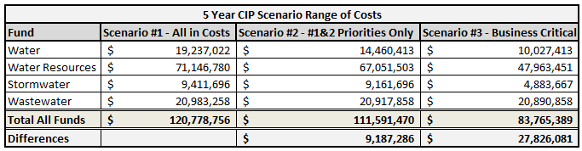

Utilities used scenario 1 in modeling rates and fees.

Staffing, energy, Long Term Operating Cost Risk
Staffing, energy and long term operating costs can also be a large risk for the Utility. In terms of staffing, the Utility currently doesn’t have enough employees to complete all the needed capital projects. The Utility evaluates the requests for staffing each year and determines the viability of costs for adding additional staff members. If costs are too high the Utility may not be able to obtain needed staff members to complete the CIP. Also if revenues decrease significantly there is always a possibility of the risk of having to decrease staffing levels. Energy and long term operating costs can be unpredictable which can cause a risk for expenses. Overall the Utility is aware of expense risks and how these are tied to revenues and is working to track these more closely over time and will adjust forecasts as needed.

Regulatory Risk
Regulatory risk is another important factor for the utilities. There are ever changing regulations with which the utility must remain in compliance. Changing regulations can cause a risk if compliance cannot be achieved in time. Also it can be costly to remain in compliance as the regulations change or as updates are needed to the system as well.

Staffing Projections

Each year the Utility works to update its current staffing projections. This is part of the annual rates and fees study. The Utility creates business cases including cost projections for each proposed new staff, which are then presented to the director for consideration. The need for the new staff is considered as well as the increased costs to the rates and fees for the future. For 2015 six new staff members were approved. For 2016 five new business cases have been presented and are being considered. The current projections created in 2015 have 17 new FTEs projected over the next five years through 2020. The Utility will look at the need and cost of these very closely and will work to determine the best staffing levels based on growth and demand on the system. Overall the department continues to grow in revenues and expenses which in turn will cause a need for growth in staff numbers. The long term staffing plan is attached in exhibit A.

Energy Consumption

Energy in the form of electricity used for pumping water from underground, treating water and running overall operations is the second largest operational expense for the utility (second to labor) and energy management has been a focus for years. An energy management plan was prepared in 2013 to document the efforts made to date and to identify other means of reducing energy costs. Some of the energy saving measures implemented to date include:
- Ensuring each electric utility account is set up with the most economical energy rate
- Coordinating start-up and shutdown of facilities to align with the electric utility billing cycle
- Implementing time of use energy plans to take advantage of off-peak energy rates
- Lowering thermostats on electric heaters at remote facilities
- A savings of over $500,000 was achieved in 2014
The Utility will continue to optimize processes to reduce energy costs and improve operating efficiency.

Revenue and Expense Comparison
Overall the Utility has set in place monthly tracking of actual revenues for the current year, comparing them to last year’s revenues to determine any impacts that are being faced based on the above risks. The Utility is also working towards better predictions of future revenue streams in the yearly planning process.

Total Revenue Comparison:

By Fund Revenue Comparison:

*The large revenue for January 2014 is from the $1.35 million Interfund Loan from the Water Fund.

Total Expense Comparison:

*The large expense for August 2014 is from the $8.0 million Interfund Loan from the Water Fund to Transportation, $3.5 million Interfund Loan from Water Resources to Transportation and $3.0M Interfund Loan from Wastewater to Transportation. Also a large WISE Infrastructure expense in Water Resources occurred.

By Fund Expense Comparison:

*The large expense for August 2014 is from the $8.0 million Interfund Loan from the Water Fund to Transportation.

*The large expense for August 2014 is from the $3.5M Interfund Loan from Water Resources to Transportation and a large WISE Infrastructure expense.

*The large expense for August 2014 is from the $3.0 million Interfund Loan from Wastewater to Transportation.

Actuals versus Budgets: Operational and Capital

Tracking of actual costs versus budgets for the Utility is an important component of financial management. Having actual expenses come in at or under budgets for each year is an area where the Utility will track throughout the year and reevaluate throughout the year. The budget and actuals for 2014 and projected budget for operational and capital expenses are shown in the table below. This shows that the actuals are well below the 2014 budgets as well as the fact that the 2015 budget decreased for capital and only increased for operational expenses by 4%. Operational expenses increased by about the same percentage as the increase in customers.

Category | 2014 Budget | 2014 Actuals | 2015 Budget
Capital | $45,352,385 | $20,805,532 | $23,134,442
Operational | $18,220,005 | $15,387,670 | $19,004,728

For capital projects the top projects that make up the totals from year to year can change, as shown in the table below. For 2014 the top projects that were worked included the WISE Infrastructure, Alternative Source of Supply, PCWRA Capital Buy In, Plum Creek Water Purification Facility and Aquifer Storage and Recovery. These made up 87% of total actuals for capital. In 2015 the projected top capital projects include the Utilities O&M building, Alternative source of Supply, Advanced Oxidation Facility, PCWRA Capital Buy In and WISE Infrastructure. These projects make up 68% of the total capital budget for 2015.

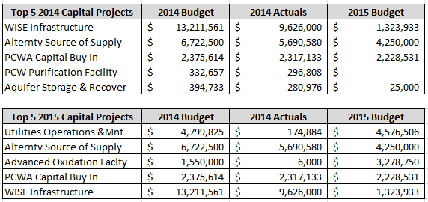

For operational expenses the top costs year to year tend to stay fairly steady as shown in the table below. The top ten costs for 2014 actuals total to 82% of total operational costs and the projected budgeted costs for 2015 total about 76% of operational costs. The breakout of these costs includes salaries and benefits, treatment costs, electricity, operating supplies, repairs and maintenance costs.

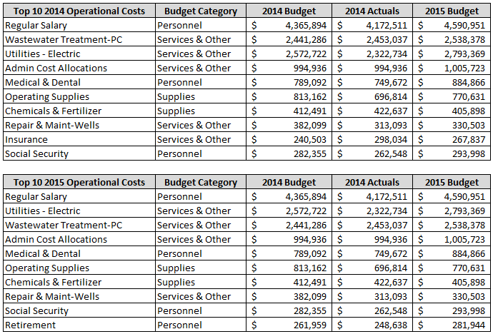

Key Performance Indicators- Budget and Operations

Operating Ratio
The operating ratio KPI is calculated using the total Operating & Maintenance (O&M) costs divided by the Total Operating Revenues. The Utilities’ 2014 operating ratio is calculated at 50% as compared to 29% in 2013. The current first quarter of 2015 is calculated at 44%. The operating ratio is in the top quartile for each time period as compared to the AWWA benchmarking, where the top quartile is anything less than 46%. This tells the Utility that the operating costs are using 50% of the current operating revenues only which is good for the utility since the goal is to come in at or under budget each year.

Energy Consumption Efficiency (Water)
The energy consumption efficiency (water) KPI is calculated using the energy consumption (kBTU) divided by the average daily production times 365 days. For 2013 the KPI was at 41,105 and for 2014 it was at 38,938. This places the utility in the bottom quartile of the AWWA benchmarking, which is set at 8,197. This tells the Utility that the energy used is higher than the average for the AWWA benchmarking. This makes sense due to the energy costs to pump water from our deep Denver Basin Aquifers. It also tells the Utility that there has been success in conserving energy from 2013 to 2014. The goal is to continue seeing improvements in energy consumption year over year.

Water Operational Cost ($/MGD)
The water operational cost ($/MGD) KPI is calculated using the total O&M costs divided by the average daily production times 365 days. The KPI for 2013 was at 3,788, for 2014 it was at $2,674 and for the first quarter of 2015 it is at $2,520. This is a good trend with costs coming down. These KPIs fall in line with the middle to bottom quartiles for the AWWA which are between $2,240 and $3,544. This KPI shows the operational cost of potable water services or costs per million gallons per day. This means that potable water services are more expensive for the Utility than for Utilities nationally. The goal is to work towards improving these costs year over year.

Wastewater Operational Cost ($/MGD)
The wastewater operational cost ($/MGD) is calculated using the total O&M costs divided by the average daily production times 365 days. The KPI for 2013 was at 3,818, for 2014 it was at $2,879 and for the first quarter of 2015 it is at $1,867. These KPIs fall in line between the top to bottom quartiles for the AWWA which are between $1,535 and $3,793. This KPI shows the operational cost of wastewater services or costs per million gallons per day. This means that wastewater services are average for the Utility compared to Utilities nationally. The goal is to work towards improving these costs year over year.

Rates and Fees

Introduction

Utilities manages four enterprise funds including the water, wastewater, water resources and stormwater enterprises. They are financially self-sufficient funds where revenues from rates and fees must cover expenses. Rates and fees have been established for each enterprise to meet expenses. One of the key goals of Utilities is to maintain the lowest possible rates and fees while covering all expenses and meeting the community’s expectations regarding levels of service. Keeping these rates and fees competitive with surrounding communities is also extremely important.

Rate Structure

The water fund utilizes a water budget rate structure which encourages the efficient use of water and includes variable and fixed rate components. The wastewater fund piggy backs off of the water budget rate structure with a variable and fixed component. Both water resources and stormwater have fixed fees. All our enterprises charge system development fees for new growth. More on rates and fees can be found in the latest version of the annual rates and fees study.

AWMC Reset
As a part of the water and wastewater enterprise rates and fees, Utilities calculates an annual winter monthly consumption for all of our customers. AWMC (Average Winter Monthly Consumption: Calculated for each customer by dividing the total water used in the months of November, December, January, and February by four (4)). This represents the amount of water for indoor use (Tier 1) and the amount of wastewater treated each month. The AWMC is reset annually on the April statement. For new customers, until an individual AWMC is established, an average for the customer class is assigned for water and a $36 per single‐family equivalent (SFE) monthly fee is charged for wastewater. Example: For single‐family residential customers, the average AWMC is 5,000 gallons (water available at Tier 1) and the monthly wastewater charge is $36. No retroactive adjustment is made to the service charges imposed prior to establishment of the usage rate. The establishment of an AWMC for each utility customer may be appealed in accordance with the procedure identified in Section 13.14.080.

Rates and Fee Study

The Utility conducts annual rates and fees studies in order to update rates for customers. The Utility believes that it is in the best interest of customers and the department to update these once a year in order to keep the most accurate rates for the customers reflecting the true cost of service and for the Utility to keep up with needed CIP projects and costs. The Town has worked with Arcadis, U.S., Inc. as an outside consultant each year on this study.

Some of the major assumptions for the 2015 Rates and Fees study include that growth pays for growth, the Utility will not issue any new debt, fund required capital plan from fund balances and rate and fees, smooth required rate adjustments over the study period to minimize rate shock, continue to fund capital plan for the current hybrid renewable water projects, utilize current town growth forecast, use operation budgets consistent with maintaining levels of service as customer base and infrastructure grows and use escalation on operational and capital costs assumed at 3.4% each year (for reference inflation has averaged 2.6% over the last ten years and the Construction Cost Index has average 4% over the last ten years).

Other key assumptions include:
- Interest on fund balances at .04%
- Variable rate debt interest at 3.35%

Arcadis, U.S., Inc. worked with the Utility to create an e-Forecast model, which compiles all the necessary data needed for the study. Included in the data provided by the Utility to Arcadis, U.S., Inc. is an updated Customer Characteristics study, which shows the trends of customers from one year to the next in all four enterprise funds as well as growth projections. The data for the Customer Characteristics memo is compiled by meter types, customer classes, consumption, etc. to provide a complete picture of the customer base and the total consumption being used.

Also included in the model is an updated long-term Capital Plan. This includes anticipated capital projects out to 2050 with the expected costs to go along with them. These projects are compiled and analyzed to determine which items make sense with future goals and also to help maintain or stabilize rate growth. Another large component of the study is an updated five year financial budget plan including current year end estimates; these are updated to reflect anticipated budget needs in all areas of all four enterprise funds. Each of these components is included in the models to determine how revenues and expenditures are changing year over year and how this will affect rates over a long period of time. A rates and fees study is produced with recommended rate changes and is presented to Council each year for approvals. Once rates are approved for the year these will then go into effect on January 1st.

Special Charges
Each year the Utility reviews special charges to ensure that they operate on a true cost of service model and provide equitable service to all customers. The special charges should recover the actual cost of service delivery consistent with cost of service principles and Town financial policies. The goal is to recover costs directly from the customers that access those services and help manage demand for those services and address customer behavior patterns. These charges include delinquency and collections charges, administrative fees and meter services related service charges. These are reviewed and calculated using total staff time, staff benefits, staff pay grades, vehicle use, depreciation, fuel and maintenance and all related materials and applicable postage costs. Once calculated the costs were compared to the current charged and costs of service to recommend the new rates. These are also benchmarked against other Front Range Area water providers. This will be done each year and adjusted as needed along with the rates and fees study.

Rate Increases/Decreases

The primary goal is to keep rates as steady as possible, while also balancing the revenue and expenditure needs of the department. At the end of the 2014 rate study, there is an average rate increase predicted per year of about 2% between all funds. Each year the rates and fees are presented to Town Council for approval, which determines the rates set for the next year. Rate recommendations are based on the annual study conducted by the Utility and Arcadis, U.S., Inc. The main goal with rate changes is to keep the revenues at a level for the Utility that will cover the cost of service including capital costs for replacements, improvements and renewable water. Another key goal with respect to rate charges is to keep the affordability level in line with the community’s needs. Overall, rate increases are foreseeable in the future in order to achieve the Utilities’ goals and objectives.

Rates Hybrid Model

In 2013 the Utility created a Hybrid model for rates that was then presented to and approved by Town Council. This is used to model and compare rates and fees and capital projects going forward based on the long term renewable water capital plan as of 2013. The hybrid model provides a standard for how monthly residential water and water resources rates would increase over five to ten year periods as shown in the chart below. Utilities’ is using this as a tracking standard / comparison tool for the Utility to determine if yearly rate increases are in line through 2050. It also helps the Utility when creating the rates and fees models to adjust CIP and other budgets and costs to align rates close to the set hybrid model. In the chart below the column showing the 2013 Hybrid is the initial comparison column. The rest of the years are how the Utilities’ rates have come in and these can be used to compare the different year’s rate changes.

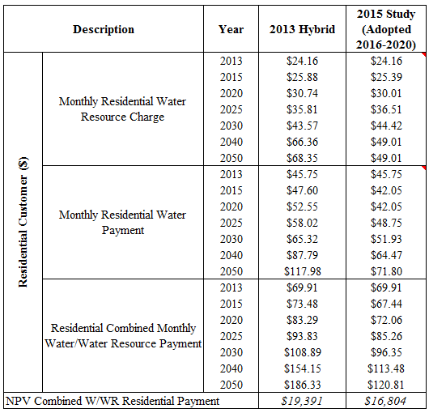
The current numbers mean that near term the numbers appear to be tracking well. Utilities will need to focus on how the out years are changing and the causes of these changes, including the increased capital charges and operating expenses. This drives the utilities to look and determine how to get back to the 2013 Hybrid numbers or how to be better than these each year. This pushes towards the need to evaluate the rates and fees each year to ensure these goals are met.

Competitive Rates with Surrounding Communities

Each year the Utility completes a benchmarking comparison on rates and fees and average bills with surrounding communities. Recently this was completed for 2015. Some of the surrounding communities include Arapahoe County, Centennial, Parker, Fort Collins, Denver, Cherry Creek, Meridian, Roxborough and many others.

As seen in the chart below in terms of billing rates Castle Rock came in slightly higher than the average of $47.37 at $51.08 for total fixed charges.

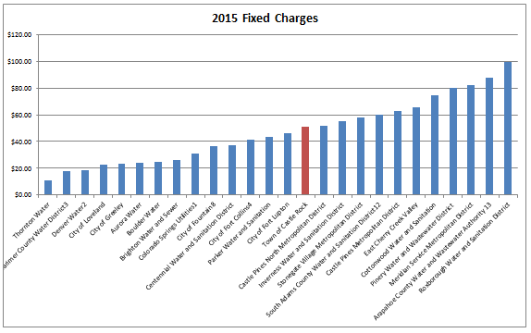

When looking at an average monthly bill for 5,000 gallons consumption and an AWMC of 5,000 gallons during a non-irrigation month, Castle Rock comes in at $65.54 total monthly bill average. This is below the average for all communities that are compared at $68.99.
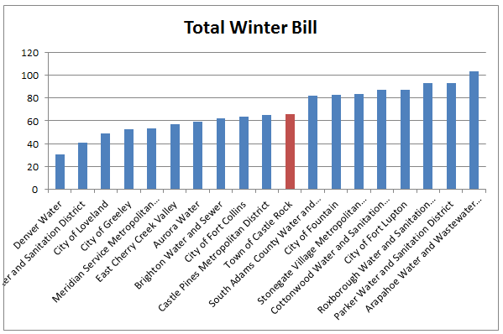

When looking at an average monthly bill for 15,000 gallons consumption and an AWMC of 5,000 gallons during an irrigation month, Castle Rock comes in at $119.44 total monthly bill average. This is above the average for all communities that are compared at $109.14.

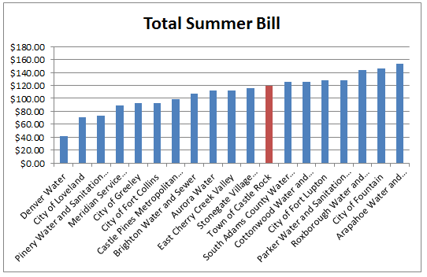

Overall this shows that the Utility is close to being within average of the surrounding community in terms of cost in winter and summer months. The utility understands that there are some communities that will come in less expensive and some that will be more expensive, but this is explained due to the different services offered, the different long-term obligations and the types of water resources available to each community.

Affordability Index

One of the goals of the Utility is to keep the rates and fees affordable to all customers. Affordability was evaluated using the United States Environmental Protection Agency’s (EPA’s) index in the 2013 study, which for wastewater is anything at or below 2%. Rates and fees were estimated to be 1.50% of Median Household Income (MHI) or less throughout the study period in 2013 as shown in figure 1. Looking at the 2015 rate models, affordability using this index is estimated to be at 1.50% or less throughout the study period.

Figure 1
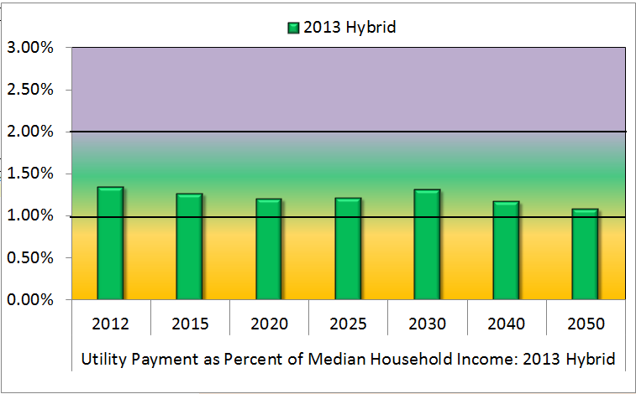
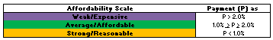

System Development Fees (SDF)

System development fee is a general term used to encompass water, water resources and wastewater system development fees (SDFs) and Stormwater development impact fees (DIFs).
Water, water resources and wastewater SDFs are assessed at the time of permitting for the right to access existing system capacity or for payment of a proportionate share of the capital cost to add capacity to meet the potential demand the new customer is expected to place on the system. Also paid at permitting, DIFs are a proportionate share of the cost to add Stormwater capital facilities to manage the runoff created by the impervious surfaces of new construction in the Plum Creek or Cherry Creek Basin.
Pursuant to Municipal Code 13.12, water and wastewater development fees are as follows:

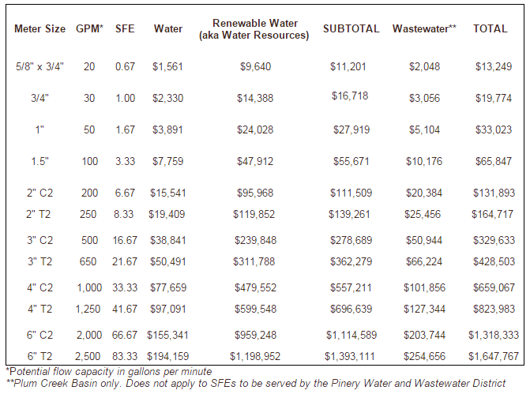
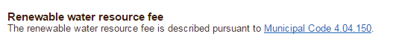
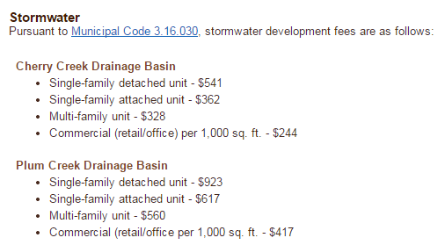
SDFs are evaluated during each annual rates and fees study. New rates for these are approved by council and placed into effect by January 1st or the year they pertain to. Each study analyzes current trends and data and uses this information to determine the most applicable fees for the Utility to achieve the projected financial goals. These fees help to ensure that costs are being recovered and that development pays for development.

Competitive Fees with Surrounding Communities

Each year Utilities compares our system development fees for new growth to surrounding communities as well. In the chart below related to system development fees the Utility is below the average of $22,019 at $20,697 in total charges.

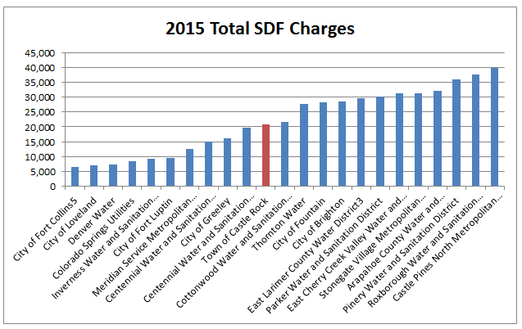

SDF Hybrid Model

As with rates below is a comparison back to the 2013 Hybrid numbers showing the goal comparison to where the Utility is working to come in at or under each year. The results indicate that SDFs are tracking below the numbers projected in the 2013 model. This is a positive result and Utilities will continue to manage towards this goal.
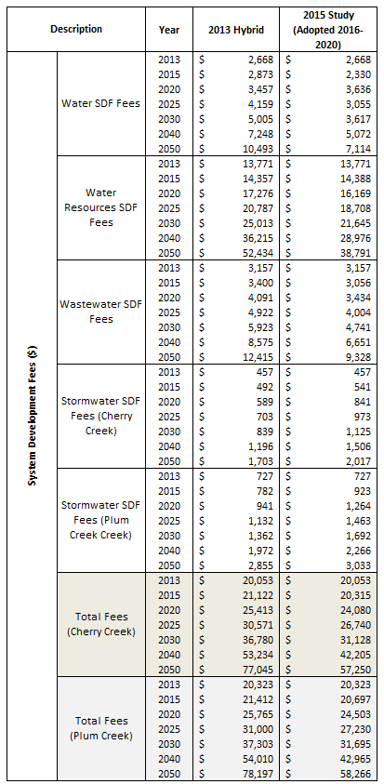

Balance Sheet

Accounts Receivable Management
Over the last several years the Utility has worked to clean up accounts receivable and to put new processes in place that allow for this to be maintained going forward. The Utility has completed an audit of accounts receivable which in turn allowed for cleanup of all old account receivable balances. Some of the processes that are now put into place to keep these items clear include following a disconnection process, a lien process, assessing late charges and having a process when accounts have non-sufficient funds (NSFs) on them.

These processes for accounts that are 30 days past due and that have NSFs on them include disconnections. These accounts will receive late fees and disconnection notices on them. This also includes a dispatch/disconnection fee if the water is turned off. In order to turn water back on the customer must make a full payment of all amounts due. If the account is still not paid then the Utility will place a lien on the property. If an account receives an NSF they will be required to pay by cash or certified funds. The utility does offer a payment agreement once in a twelve month time period if needed, but will still disconnect if the agreement is broken. These items are all in place in order to help protect the Utility and to keep accounts paid and to avoid an accounts receivable that grows to a large amount again.

The Utility has made great strides and keeps working towards success with accounts receivable management. The Town is always reviewing current processes to determine if there are ways to improve these or if what is being done should be maintained. Everyone involved is committed to keeping accounts up to date and working with customers while following policies and procedures.

Utilities Accounts Receivable (AR) Turnover ratio plan is to keep within 90 days or less. Statistics have been calculated since January of 2012 showing the drop from 208 days turnover to 54 days currently. Keeping the turnover ratio at 90 days or less is a good business practice for the utility and allows for clean record keeping and revenues being collected with a quick turnover ratio.

Other Financial Management Tools
Some other audits the Utility has completed or is the process of working through include a senior discount audit and a large meter audit. These both are important to determine if accounts are receiving appropriate charges or discounts. These help to find any errors in the system or in the hardware used by customers. The Utility is using its current resources to complete due diligence with account maintenance, billing, set-up and tracking to help keep records accurate.

Interfund Loans
Currently Utilities has five outstanding Interfund loans. The management objective of Interfund loan options is to provide short term cash to projects which benefit the Utility or the Town. These also provide a higher short term interest than leaving the cash in reserves. The key is the loans must be very short term in nature to ensure that cash is available when needed for the project for which it has been reserved. These include:
- A two year loan from the Water Fund to the Transportation Capital Fund in the amount of $8,000,000 at an interest rate of 1.5%. This is due to mature in 2016 and is to help finance a portion of the North Meadows Extension Project.
- A five year loan is from the Water Fund to the Stormwater Fund in the amount of $1,350,000 at a 1.5% interest rate and is expected to mature in 2019. This is to help finance a portion of the Tributary B Stabilization Project.
- A two year loan from the Water Resources Fund to the Parks Capital Fund in the amount of $875,000 at a 1.0% interest rate and will mature in 2015. This helps to finance a portion of the Phillip S. Miller Park Project.
- A one year loan from the Water Resources Fund to the Transportation Capital Fund for $3,000,000 at a 1.5% interest rate and matures in 2015. This loan is to finance a portion of the North Meadows Extension Project.
- A one year loan from the Wastewater Fund to the Transportation Capital Fund in the amount of $3,000,000 at a 1.5% interest rate. It will mature in 2015 and helped to finance a portion of the North Meadows Extension Project.
Utilities will continue to manage interfund loans to maximize interest on reserves, minimize the need for issuing debt and helping to implement the CIP for each enterprise.

Deferred Revenues
The Utility has a few deferred revenues on the balance sheet. These are typically used as prepaid accounts from developers. The current primary deferred revenue accounts are for the Utilities’ lift stations under the Wastewater Fund, where prepaid revenues have been collected up front and payments are made in 20 year increments on December 31st of each year. They are used to collect funds from developers for the operation of the lift stations in Utility service areas that need additional service to have the water flow correctly. The current accounts include the Meadows 15 Lift Station, the Meadows 17 Lift Station, the Castle Oaks Lift Station and the Castlewood Ranch Lift Station. The yearly accruals on these total $29,510 and mature in 2026 and 2027. Similar to the lift stations is the Woodlands Interceptor Deferred Revenue account. This works in the same manner, except $940 is collected per new permit issued. It will mature in 2017 and the 2014 accrual amount was $27,269. Other forms of deferred revenue are for the Meadows and Woodlands Capital Reserves in the Water and Wastewater Funds. The Capital Reserve Funds are monies received from the developers for the developing, restoring, rehabilitating, improving or repairing any Water or Wastewater facilities utilized, in whole or in part, to provide water or irrigation services to those specific areas. The current amount as of December 31, 2014, in the Meadows Capital Reserve is $4,686,154 and $162,519 in the Woodlands Capital Reserve. The goal with all of these reserves is to utilize these reserves to rehab, maintain and improve the capital assets for which the reserves were collected for the benefit of the customers served by the asset.

Other key financial agreements include the Dominion Lease Purchase and the Chatfield Option. These projects have been put into place to help with the long term water goals for the Utility. With the Dominion Lease Purchase the Utility receives $129,000 a year in lease payments from them. With the Dominion Wheeling agreement the total received is $675,000 from Dominion. The Chatfield agreement will allow the Utility to use water storage space in Chatfield, which provides close storage space for future water. These financial agreements help to meet the goal of reducing the long term costs to our customers.

Fixed Assets
The Utility has a significant amount of capital assets currently valued at approximately $550 million. One of the main goals for the Utility is to consistently track and maintain these assets and the useful life of each. The Utility is working towards using the AWWA industry standards in setting accurate and consistent useful life values. The Town finance department works to determine the correct depreciation schedules for the current assets and updates yearly for the Utility. The Utility will continue to work with Town staff to ensure the financials are up to date, accurate and consistent including validation of the fixed asset list and timing of disposals and transfers.

The Utility’s assets for year end 2014 for all four funds were $553 million. The total liabilities for each fund at year end 2014 were $94 million. The total net position for all four funds at year end 2014 was $460 million. The utility anticipates these to increase as the CIP projects are completed and booked as fixed assets. The Utility works with the finance department to ensure this is completed and updated accurately.

Exhibit A
Long Term Staffing Plan

